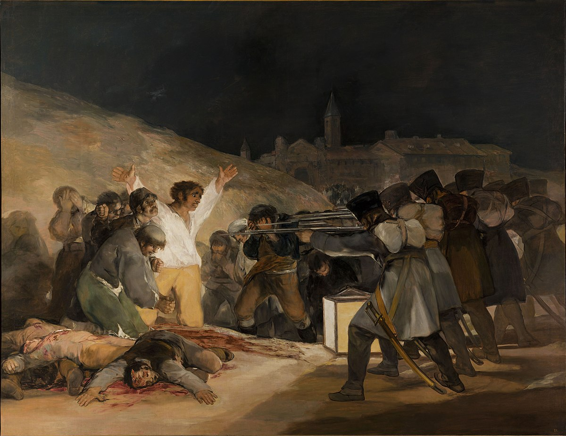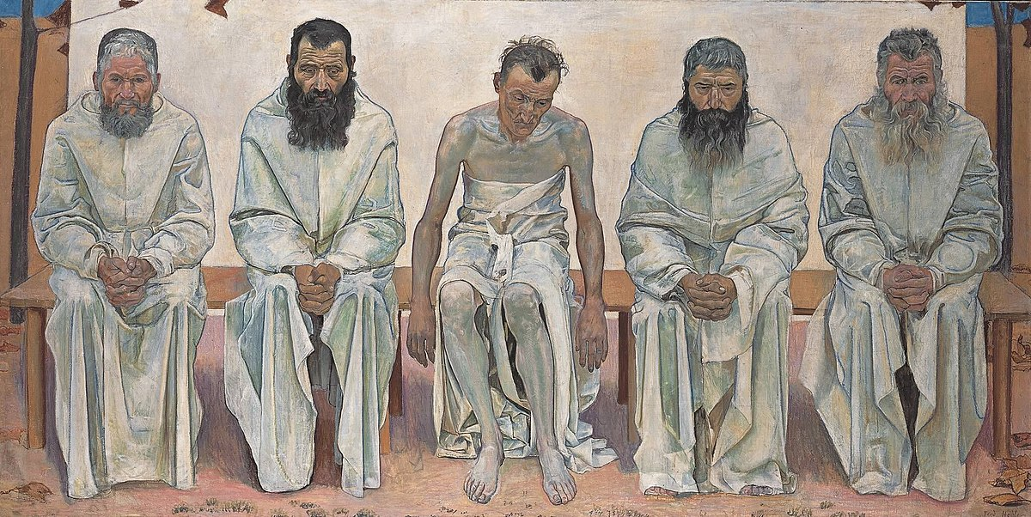



References:

<https://smarthistory.org/goya-third-of-may-1808/>

<https://www.artsy.net/artwork/ferdinand-hodler-the-disappointed-souls-les-ames-decues>

<https://arthur.io/art/ferdinand-hodler/the-disappointed-souls>

<https://arthive.com/ferdinandhodler/works/332800~Tired_of_life>

<https://commons.wikimedia.org/wiki/File:Ferdinand_Hodler_Die_Lebensm%C3%BCden.jpg>